How to start new Django Project

this is in the cmd

1. Go to the directory where you want to make the project (Django folder for me)

2. type django-admin startproject (name of project not including the parenthesis)

3. make a directoy called "apps" using (nul> apps) or (touch apps)

4. go inside apps directory and make a file called "__init__.py"

5. in this apps directory you can make a new app by typing python ../manage.py startapp (name of app)

6. go to the setting.py file inside the project directory alongside manage.py and apps directory

7. add to the installed apps list "apps.(the name of the directory inside of apps from step 5). DONT FORGET THE COMMA!!

8. go to project directory that is alongside the apps and manage.py and open the urls.py

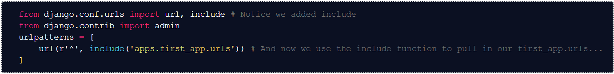

In the above, change the first_app to whatever the name of the app is

9. go to apps/(name of app directoy) and touch a “urls.py”

10. open urls.py and add

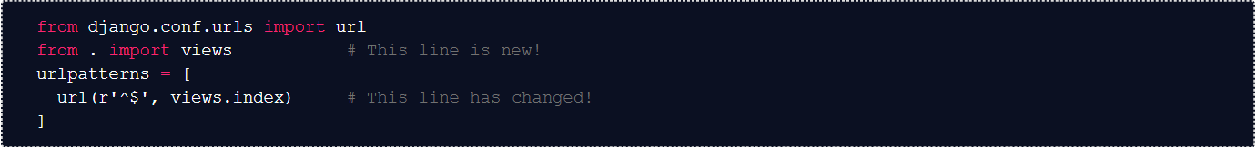

To add a new route, add it between the ^ and $ above and change index to match to def in the views.py that you want it to go to

11. now just start working on the project using the second urls.py and the views.py and other files if you need to.

Static and templates:

Add both of those directory along side migration directory under project directoy which is under apps. **So apps/project directory**.

Inside each directory make another directoy with the same name as the project directory name and then put the html or css or js files in there. **REMEMBER TO DO IT LIKE THAT**